Organic Chemistry 19-20
Semester 1 Final Exam Study Guide

- The final exam will be all multiple-choice and true false.
- Do not bring electronic devices to the exam. This includes cell phones, tablets, game systems. If I see them I will take them.
- There will be no rest room passes until you are done with the test.
- This study guide will be worth daily points for completing the assigned portions.
- BRING A PENCIL!!! Don’t come to your final without one.

“Success is a state of mind. If you want success, start thinking of yourself as a success.”
- Keys to success:
  - Review old labs and homework.
  - Complete this study guide using notes, labs, diagrams, the book, and old assignments.
  - Don’t wait until Wednesday or Thursday before finals to get help.
  - Start studying early. Remember, you have all winter break to relax.
  - Use old study guides in addition to this study guide for help and extra practice. Be sure to focus on what this study guide covers, but those old study guides help a lot.
  - Be prepared.
Final exam will cover chapters 1, 2, 3, 4, and 7.
1st Semester Finals Schedule
Wednesday, January 15th |  |  | Thursday, January 16th |  |  | Friday, January 17th
Resource | 8:10-9:40 |  | Resource | 8:10-9:40 |  | Resource | 8:10-8:45
5th period | 9:50-11:20 |  | 1st period | 9:50-11:20 |  | 3rd period | 8:50-10:20
6th period | 12:20-1:50 |  | 2nd period | 12:20-1:50 |  | 4th Period | 10:30- 12:00
7th period | 2:00-3:30 |  | Resource | 2:00-3:30 |  | Busses Leave | 12:30
 |  |  |  |  |  | 8th period  make-up | 12:30-3:30

Chapter 1 Bonding & Isomerism (18 Questions):
- What charge does the ion carry when each of the following elements reacts to form an ionic compound: Al, Li, S, H.

- Which is the more electropositive element: Na or Al, B or C, B or Al. (Circle correct choice.)

- Which is the more electronegative element: O or F, O or N, F or C. (Circle correct choice.)

- For (CH₃)₂CHCH₂OH , list the following::
  - Molecular formula

  - Abbreviated/condensed structural formula

  - Full structural formula

  - Skeletal formula

  - Line segment

- Diagram the polarity of the N-Cl bond and of the S-O bond with δ+ and δ-.

- Draw the full structural formula of the refrigerant dichlorodifluoromethane and indicate the polarity of the bonds.

- Draw the formula for methanol, CH₃OH, and (where appropriate) indicate bond polarity with an arrow, .

- Draw the Lewis Electron Dot diagram for H₂CO

- Draw skeletal formulas for three different molecules that have the formula, C₄H₈, and have one carbon-carbon double bond.

- Does C₂H₅ represent a stable molecule?

- Draw structural formulas for all isomers of C₃H₈O (there are 3).

- Write a structural formula that shows all bonds for CCl₂=CCl₂

- Write a line-segment for (CH₃)₂CHCH(CH₃)₂.

- What functional groups can you find in the following natural products? (Their formulas are given in Figures 1.11 and 1.12, pages 33-34)
  - geraniol b. muscone c. limonene d. testosterone

- Are the following ionic or covalent? If covalent, is it polar or non-polar?
  - Br₂
  - LiBr
  - SiCl₄
  - KCl
  - PCl₃
  - P₂O₅

- How many valence electrons does each of the following have, and what is its valence?
Element | Oxygen | Fluorine | Carbon | Hydrogen
Valence Electron
Valence
- Draw the skeletal formulas for all isomers of C₃H₆F₂

- Write an abbreviated structural formula corresponding to the molecular formula C₄H₈O and is:
  - Acyclic b. carbocyclic c. heterocyclic

- Divide the following into groups that might be expected to exhibit similar chemical properties. List the characteristic that defines each group: C₅H₁₂ CH₃OCH₃ C₃H₇OH C₄H₉OH C₈H₁₈ CH₃OCH₂CH₃ HOCH₂CH₂OH CH₃OH C₆H₁₄

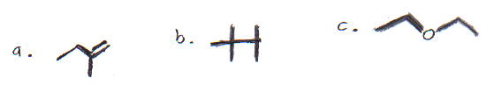
- Write abbreviated formula for:

- Arrow symbolism: What is the difference in meaning between the following 2 arrows?
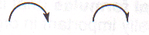

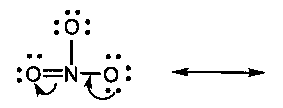
- Draw a diagram of the molecule that would be formed based on the arrows:

Thinking Critically: As you flip through your notes and past lab activities from chapter one, are there any topics left out? If so list them below and provide an example for each.

Chapter 2 Alkanes & cycloalkanes; Conformational & Geometric Isomerism (23 Questions)
- What is the molecular formula of an alkane with 20 carbon atoms? An alkene? An alkyne?

- Which of the following are alkanes?
a. C₈H₁₆ b. C₇H₁₆ c. C₇H₁₈ d. C₂₇H₅₆

- Give the correct IUPAC name for CH₂BrCl.

- Write the formula for each of the following compounds:
a. 2-chloropropane b. all alkyl fluorides

- Explain why 1,3-dichlorobutane is a correct IUPAC name, but 1,3-dimethylbutane is not a correct IUPAC name.

- Draw Newman projections for staggered & eclipsed conformations of ethane, and predict which of the two conformations is more stable.

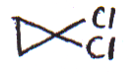
- Give IUPAC names for:
a. CH₂CH₃ b. c. Cl

CH₃
___________________ _________________ __________________

- Draw the structure for the cis and trans isomers using solid and dashed wedges:
a. 1,2-dichlorocyclopropane

b. 1-bromo-3-chlorocyclobutane

- Classify each of the following isomer pairs according to the scheme in
Figure 2.5 (structural, conformational, or configurational isomers):
a. 1-bromopropane and 2-bromopropane ____________________
b. cis- and trans-1,2-dimethylcyclohexane ___________________
- Which represents the more oxidized form of carbon, (a) methanol (CH₃OH)
or formaldehyde (CH₂=O)? (b) methanol or dimethyl ether (CH₃OCH₃)?

- Write an equation for the monobromination of methane.

- Write abbreviated structures of all possible products of monobromination of pentane.

- How many organic products can be obtained from the monobromination of cyclopentane?

- List the following in order of increasing boiling point (list lowest boiling point first)
A. 2-methylhexane B. Heptane C. 3,3-dimethylpentane D. Hexane E. 2-methyl-pentane

- Write equations for all the steps (initiation, propagation, termination) in the free radical chlorination of methane to chloromethane.

- Write the abbreviated structural formula and name for all possible isomers of:
- C₄H₁₀ (2)

B. C₂H₂Cl₂Br₂ (3)

- Write an equation for the complete combustion of hexane

- Write an equation for the monochlorination of cyclopentane

- Explain why the name given is incorrect & give a correct name:
  - 1,3-dimethylcyclopropane

  - 1,1,3-trimethylpentane

- Write skeletal formulas & names for 6 cycloalkane isomers w/the following molecular formula: C₅H₁₀

- Name the molecules below.
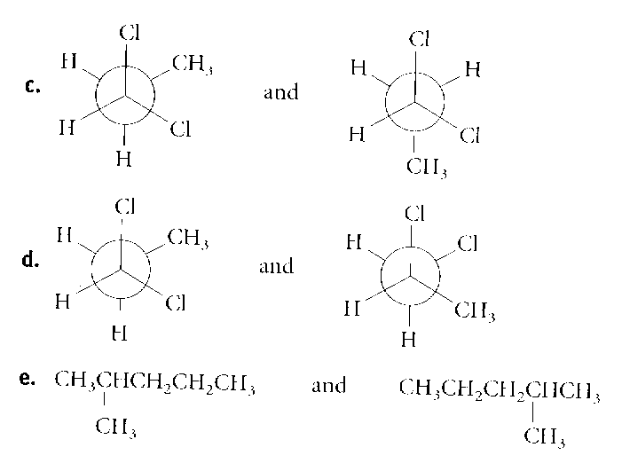
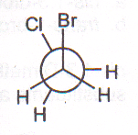

- Are the following structural isomers, conformational, configurational, or identical?

- Boat & chair isomers:
    - What type of isomers are they; conformational, rotamers or structural?
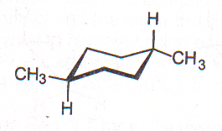
    - Is the diagram at the left a boat or chair?
    - Label each CH3 group as axial or equatorial.
    - Name the molecule, including a cis or trans prefix.

    - How would a ring flip affect axial/equatorial positions and cis/trans orientation?

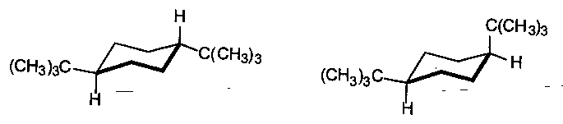
    - Which molecule is more stable? Circle it and explain why.

Thinking Critically: As you flip through your notes and past lab activities from chapter two, are there any topics left out? If so list them below and provide an example for each.

Chapter 3 Alkenes & Alkynes ( 23 Questions)
- What are all the structural possibilities for C₄H₆? (4-acyclic & 5 cyclic. List 5 of them.)

- Which of the following compounds have conjugated multiple bonds? If not conjugated, what kind of bonds are they?

- Name each of the following structures by the IUPAC system. Include cis/trans or E/Z if appropriate.

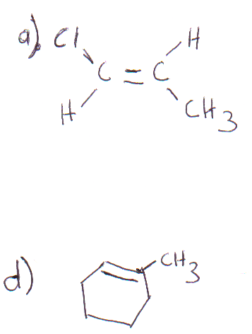
b. (CH₃)₂C=C(CH₃)₂ c. CHΞCCH(CH₃)CH=CH₂

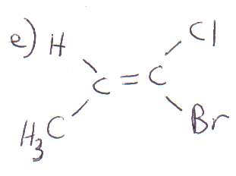

f. HC≡C(CH₂)₃CH₃

- Write the abbreviated structural formula for:
a. 2,4-dimethyl-2-pentane

b. 2-hexyne

c. 1,2-dibromocyclobutene

d. 2-chloro-1,3-butadiene

e. (E)-3-bromo-2-fluoro-2-pentene

- Which of the following compounds can exist a cis-trans isomers? Draw their structures.
a. propene b. 3-hexene c. 2-hexene d. 2-methyl-2-butene

- Write an equation for the catalytic hydrogenation of:
a. 2-methylpropene

b. 1,2-dimethylcyclobutene

- Write an equation for the reaction of bromine at room temperature with:
a. 1-butene

b. cyclohexene

- Write an equation for the acid-catalyzed addition of water to:
a. 2-butene

b. cyclopentene

- Write an equation for each of the following reactions:
a. 2-butene + HI

b. cyclopentene + HBr

- Use Markovnikov’s rule to predict which regioisomer predominates in each of the following reactions:
a. 1-butene + HCl

b. 2-methyl-2-butene + H₂O (H⁺ catalyst)

- What two products are possible from the addition of HCl to 2-pentene? Does one predominant? Why or why not?

- Classify each of the following carbocations as primary, secondary, or tertiary:
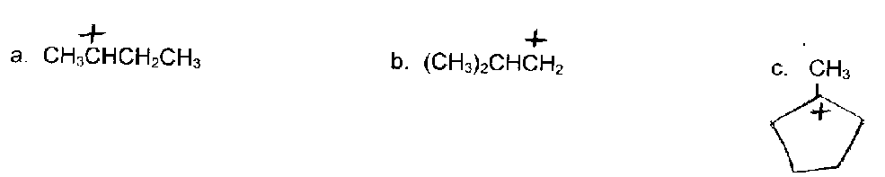

- Which carbocation in Question #57 above is most stable? Least stable?

- Explain why in the first step in the addition of HBr to 1,3-butadiene, the proton adds to C-1 and not C-2.

- Write an equation for the expected products of 1,2-addition and 1,4-addition of Br to 1,3-butadiene.

- Which alkene will give only acetone, (CH₃)₂C=O, as the ozonolysis product?

- Write equations for the following reactions:
a. CH₃C≡CH + Cl₂ (1 mol)

b. CH₃C≡CH + Cl₂ (2 mol)

c. 1-butyne + HBr (1 and 2 mol)

- Write an equation for the hydrogenation of 3-hexyne using Lindlar’s catalyst.

- What reactant will react by addition with what unsaturated hydrocarbon to form each of the following?

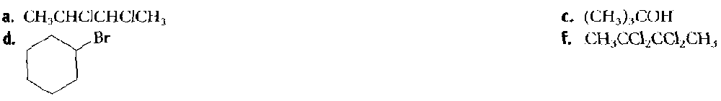

- Does a carbon with four single bonds have….
- sp³, sp² or sp orbitals around it?

- Any p orbitals around it?

- What is an sp³ orbital?

- Describe the structure of a pi bond.

  - What type of orbitals combine to make a pi bond?

  - Where do you find pi bonds in a molecule?

- What type of bond is formed between the carbon and each hydrogen in methane?

Thinking Critically: As you flip through your notes and past lab activities from chapter three, are there any topics left out? If so list them below and provide an example for each.

Chapter 4 Aromatic Compounds (24 Questions)
- Draw the structure of:
a. p-nitrotoluene b. o-bromophenol

c. m-dinitrobenzene d. 2,6-dibromo-4-chlorobenzoic acid

- Indicate the main monosubstitution products:
  - Nitrobenzene + chlorine (Fe catalyst)

  - Benzenesulfonic acid + HNO3 (H2SO4 catalyst)

  - Iodobenzene + H2SO4 + SO3

- Using benzene or toluene as the only aromatic organic starting material, devise a synthesis for the following:

  - P-bromonitrobenzene

e. P-methylsulfonicacid

74 Continued: Using benzene or toluene as the only aromatic organic starting material, devise a synthesis for the following:

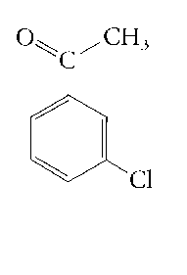

- Name:
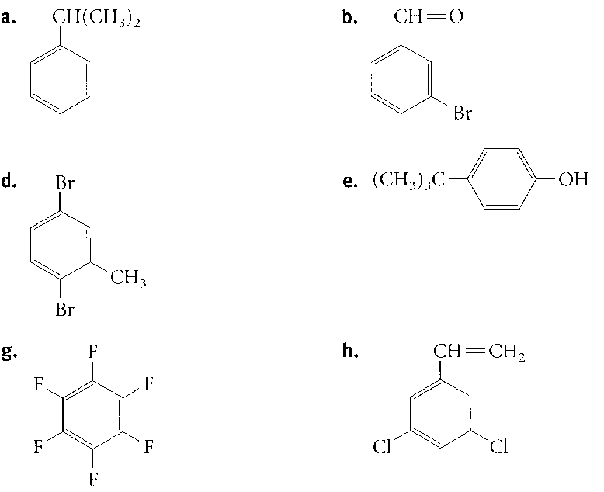

- Which compound is more reactive toward electrophilic substitution (for example nitration)?
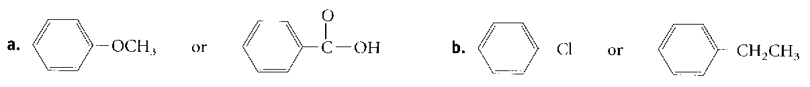

- Draw an example of each for phenol
  - O placement
  - M placement
  - P placement

- What is an activator?

  - How do you recognize them?

  - What molecules are the exception to this rule?

  - What happens to reaction rate if you have 2 activators on a benzene ring?

  - What happens to reaction rate if you have an activator with a deactivator on a benzene ring?

- What is a deactivator?
  - How do you recognize them?

  - What happens to reaction rate if you have 2 deactivators on a benzene ring?

- What is a polycyclic molecule?

  - Draw an example below:

- If m-nitrobenzenesulfonic acid is treated with CH₂ = CH₂ in the presence of H2SO4, draw and name the only trisubstituted product observed.

- If o-chloronitrobenzene is treated with HNO3 in the presence of H2SO4, how many trisubstituted products are possible? Draw & name them.

- Draw the predominant product from the sequential sulfonation and chlorination of benzoic acid.

- Devise a synthesis for the conversion of benzene to p-nitropropylbenzene.

- Write an equation for the synthesis of chlorobenzene from benzene

Thinking Critically: As you flip through your notes and past lab activities from chapter four, are there any topics left out? If so list them below and provide an example for each.

Chapter 7:Alcohols, Phenols & Thiols (23 Questions)

- Write an abbreviated formula for:
  - Cis-2-methylcyclopentanol

  - 2-methyl-2-propen-1-ol

  - 2-phenylethanol

- Name the alcohols and their derivatives by the IUPAC system:

a. BrCH₂CH₂CH₂OH b. CH₂=CHCH₂CH₂OH c. (CH₃)₃COH

d. e.

- Define an acid according to:
  - Arrhenius/Standard

  - Bronsted-Lowry

  - Lewis

- Is water an acid or a base in the following reactions? Label the conjugate acid/base pairs.

H₃PO₄ + H₂O → H₂PO₄⁻ + H3O⁺

- Which of the following are Lewis acids, and which are Lewis bases?
a. H:— b. (CH₃)₃B c. Mg²⁺

d. CH₃OCH₃ e. (CH₃)₃C⁺ d. (CH₃)₂C=O

- Classify the following alcohols
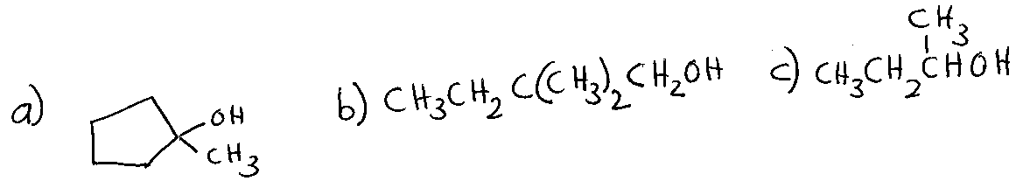

- Draw the structure for:
  - 3-methyl hexanoic acid

  - ethylpropanoate

c. p-ethylphenol

d. o-hydroxyacetophenone

- The pKa for ethanol is 15.9 and for 2,2,2-trifluoroethanol is 12.4.
  - Which is the stronger acid?

  - Based on its name, explain why it is a stronger acid.

- Rank the following five compounds in order of increasing acid strength:

2-chloroethanol, p-chlorophenol, p-methylphenol, ethanol, phenol

- Name the following molecule. Then write an equation showing its formation.

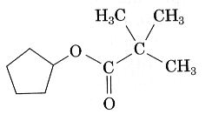

- Write an equation showing how you would prepare the following from 1-propanol:
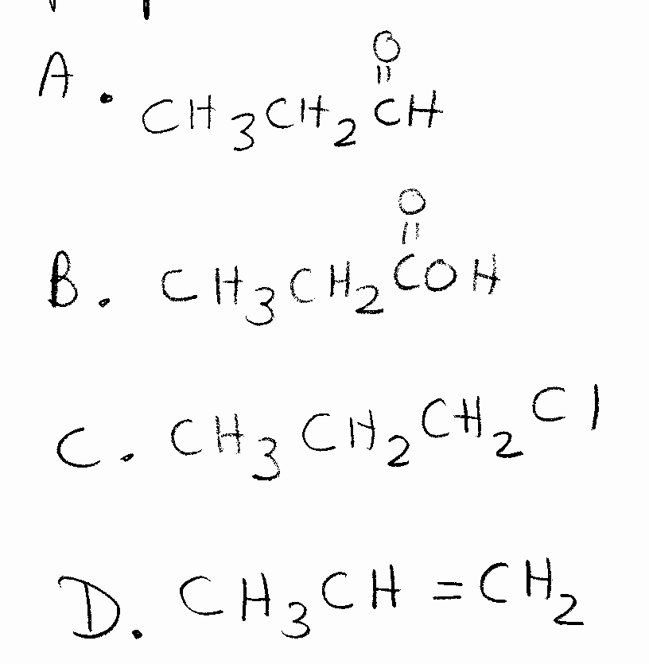

- Alcohols & their derivatives have many uses biologically and industrially. Draw a specific example or general formula for each of the following AND give a specific example in nature or a use industrially/commercially:
  - alcohol

  - glycol

  - glycerol

  - aldehyde

  - ketone

  - carboxylic acid

  - thiol

  - quinone

Thinking Critically: As you flip through your notes and past lab activities from chapter seven, are there any topics left out? If so list them below and provide an example for each.

Chapter 7:Alcohols, Phenols & Thiols (18 Questions)

- Draw the structure of glycerol.

- What is the geometry of the double bonds in an unsaturated fatty acid?

- Using the table below, label the fatty acids as saturated and unsaturated.
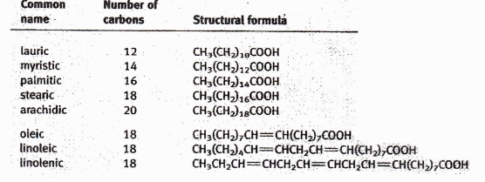
- What are the five different types/subgroups of lipids?

- What type of lipid is a salt of a long fatty acid chain?

- What ions cause hard water to form?

- Draw glyceryl myristoarachidolinoleate.

- What happens when you hydrogenate a unsaturated fatty acid?

- Circle which fatty acid below would have the lowest boiling point. below and explain why.
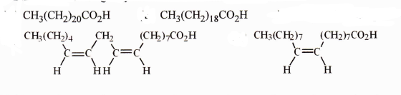

- Describe the solubility of a lipid in polar vs nonpolar solvents.

- What is the main difference that distinguishes whether lipids are classified as fats or oils?
- On saponification with sodium hydroxide, which fat or oil will yield two moles of the sodium salt of stearic acid and one mole of the salt of lauric acid?
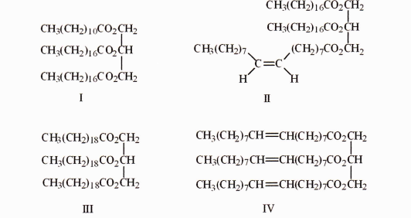

- Fill in the table below matching the type of lipid to its description. Lipid types can be used more than once or not at all.

Lipid Type | Description/Example
 | Aspirin, and other pain killers, are used to inhibit members of this lipid group.
 | Consists of glycerol, 2 fatty acids, and a phosphate/amine group.
 | Consists of glycerol and 3 fatty acids
 | Major component of cell membranes
 | Coating on leaves
 | Locally acting hormones-one type stimulates mucous production in the stomach
 | Examples include testosterone and cortisone.

- On the soap molecule below, label the hydrophilic and hydrophobic portions. Explain how you decided citing evidence of lipid properties.
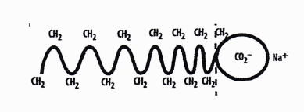
- What is one undesired result of using lipids in hard water?

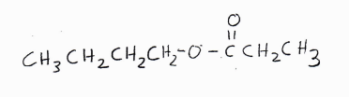
- Name the following molecule



