Review Sheet: Naming Aromatics
5
X
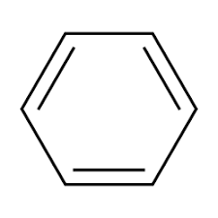
- Which position(s) is/are para to X?

3
4
1
2

- Name the following. Use common names when appropriate.

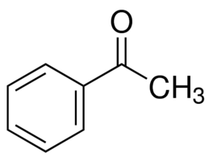 | 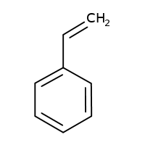 | 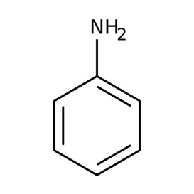
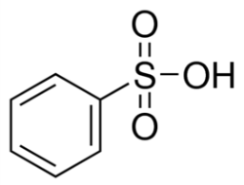 | 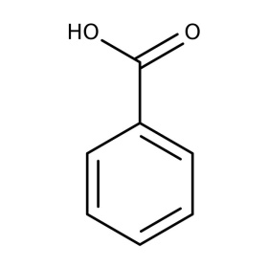 | 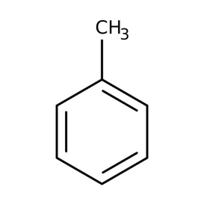
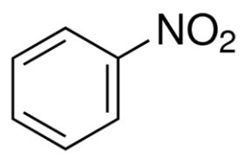 | 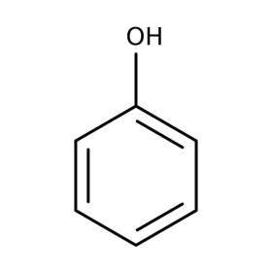 | 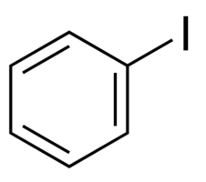
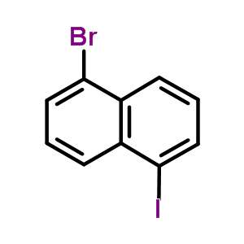 | 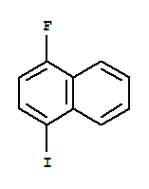 | 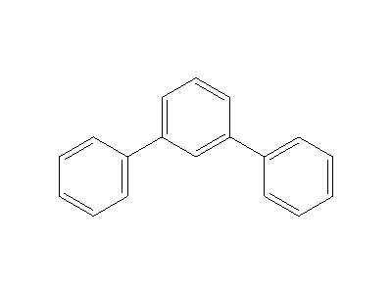

- Name the following at least 2 different ways.
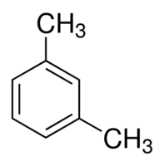 | 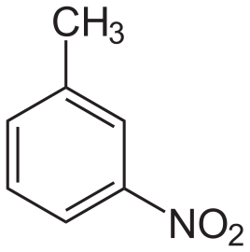 | 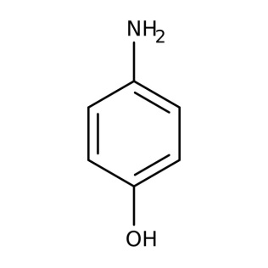
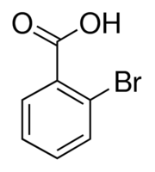 | 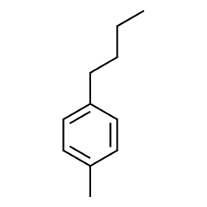 | 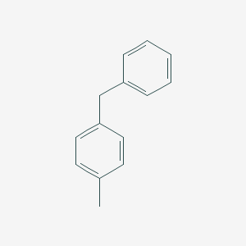

- Draw the following molecules.
o-iodostyrene | m-ethylbenzenesulfonic acid | 1,2,4-tribromobenzene
2-chloro-6-ethylphenol | 2-bromo-5-ethylacetophenone | 3-phenylhexane
6-bromo-5-phenyl-2-hexene | 2-bromo-3-phenylbutane | benzylbromide
o-diphenylbenzene | 1-fluoro-2-phenylpropane | 2,5-difluoro-3-nitroaniline
- Which of the following represents more than one compound? Why?
  - o-iodostyrene
  - iodostyrene
  - 3,5-diiodostyrene
  - m-iodostyrene

- Which of the following represents more than one compound? Why?
  - o-bromobenzoic acid
  - benzenesulfonic acid
  - chloroethylbenzene
  - 2-nitro-4-propyltoluene

- What is the abbreviation of Ph- used to denote?

